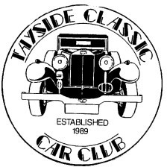Tayside Classic Car Club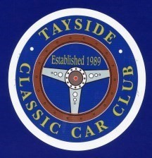

T.C.C.C are organizing our 19th Classic Motor Show at Errol Airfield on Sunday 14th June 2026. We are offering pitches for Auto Jumblers, trade stalls and bric-a-brac etc at a starting price of £20 for the size 5 meters x 5 meters. Each extra width of 1m will be charged an extra £6.00. 10 metres by 5 metres would therefore cost £50. All cheques should be made payable to Tayside Classic Car Club or the preferred method of payment being directly to our Bank – Bank of Scotland – Code 80-73-31 – Account No 00575694

Stall Holder Details

Name ------------------------------------------------------------------------------------------

Type of Stall -----------------------------------------------------------------------------------

Address ---------------------------------------------------------------------------

---------------------------------------------------------------------------

--------------------------------------------------------------------------

Phone Number ---------------------------------------------------------------------------------

E-mail address --------------------------------------------------------------------------------

Size of Stall Required --------------------- --------------------------------------------------

Fee Payment -----------------------------------------------------------------------------------

Please return by post to Jim and Mary MacLeod, 2 Mossie Park, Gowanbank, Forfar DD8
2WG or e-mail to jimary.macleod9x@tinyworld.co.uk – Telephone 01307465838 or 0772990877 for further details

